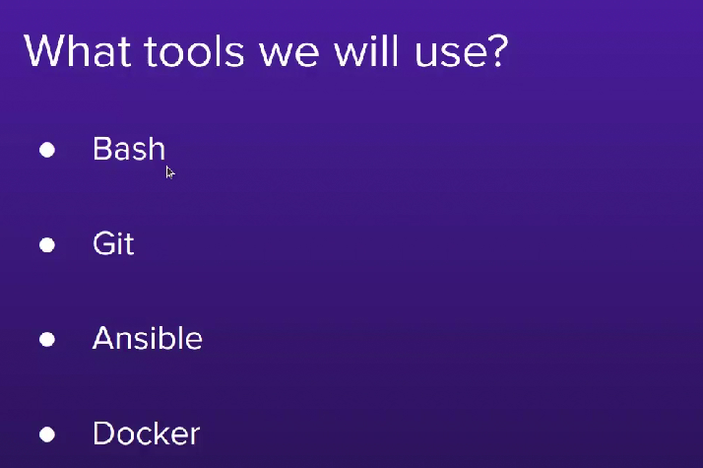

Bash:

* server use base on linux
* Ubontu
* Amazon linux
* redhat base sentous
* Debian Base

Git: head term , git structure, new brunch, brunch management

Ansible: Like a tools, CICD , server setup tools.

Docker:

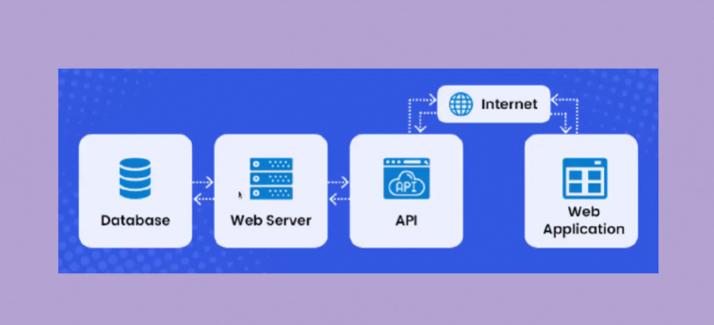

Portfolio website: git hub e host kora jai

Webserver can handle multiple request,

Development mood a application run korle multiple request handle korte parena.

Popular web srever”

* Apache
* Nginx revers proxy , multiple application. Akta server a request ase, seta multiple server a distribution
* Tomcat
* Unicorn backend server
* Gunicorn backend server

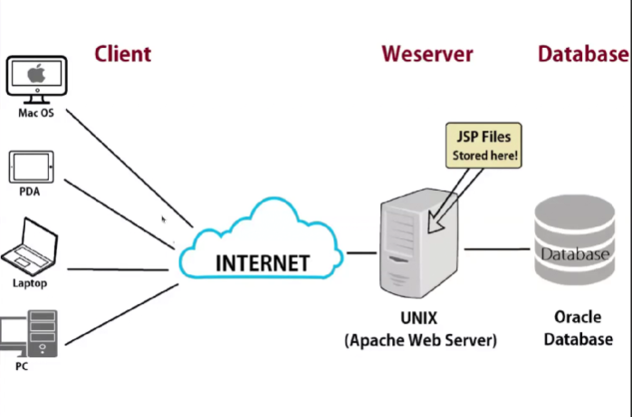

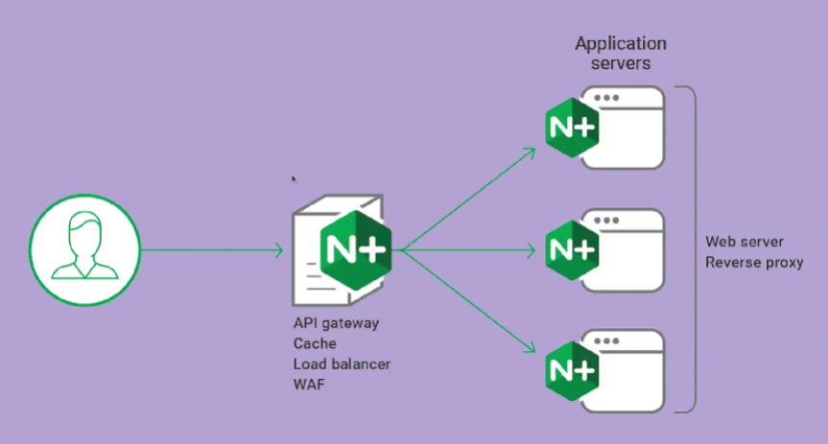

Server: resource utilize. Server

failure.

* 1 storage full. Os clops, AWS storage full support, Digital Ocean,

At a time onk request asar fol e RAM pressure hoi.

Load balance strategy(Nginx).

1 server fail doesnot matter

Server over loaded hobena

Bondo hobena

SSH (Secure Shell Protocol) “ssh-keygen”

MERN: workstation a node er jonno specific vertions install kora lagbe. Dependency install, total install er kaj ta confirure management tool (Ancible)

Debian base: sudo apt install

Redhat base:

.ini sile

Ansible ad-hoc command

